Assignment 1 - Hotdog🌭
https://github.com/max-dtu/hotdog-nothotdog

Kalo
Yuto
Matthias
Artem
Siddhant

ddl : 27/09

Before Transfer Learning:
Input: (batch_size, 3, 128, 128)
Stage 1: Conv2d(3 -> 16, 3x3) -> BatchNorm -> ReLU -> MaxPool(2x2) ==> (16, 64, 64)
Stage 2: Conv2d(16 -> 32, 3x3) -> BatchNorm -> ReLU -> MaxPool(2x2) ==> (32, 32, 32)
Stage 3: Conv2d(32 -> 64, 3x3) -> BatchNorm -> ReLU -> MaxPool(2x2) ==> (64, 16, 16)

Flatten: 64 * 16 * 16 = 16,384 features

Classifier Head:
Linear(16384 -> 128) -> ReLU
Linear(128 -> 2)

Output: (batch_size, 2) logits

- Depth: 3 convolutional layers + 2 fully-connected layers (5 layers total).
- Total Parameters: 2,121,000
- The Architectural Weakness: Notice where the weights are:
  - The 3 Conv layers only use ~24,000 weights.
  - The fully-connected layer Linear(16384, 128) consumes 2,097,152 weights (over 98% of the entire model!). Brute-force flattening into a large linear layer is prone to overfitting.

After Transfer Learning: Pretrained ResNet-18
This model has an 18-layer deep architecture with two major innovations: Residual (Skip) Connections and Global Average Pooling.
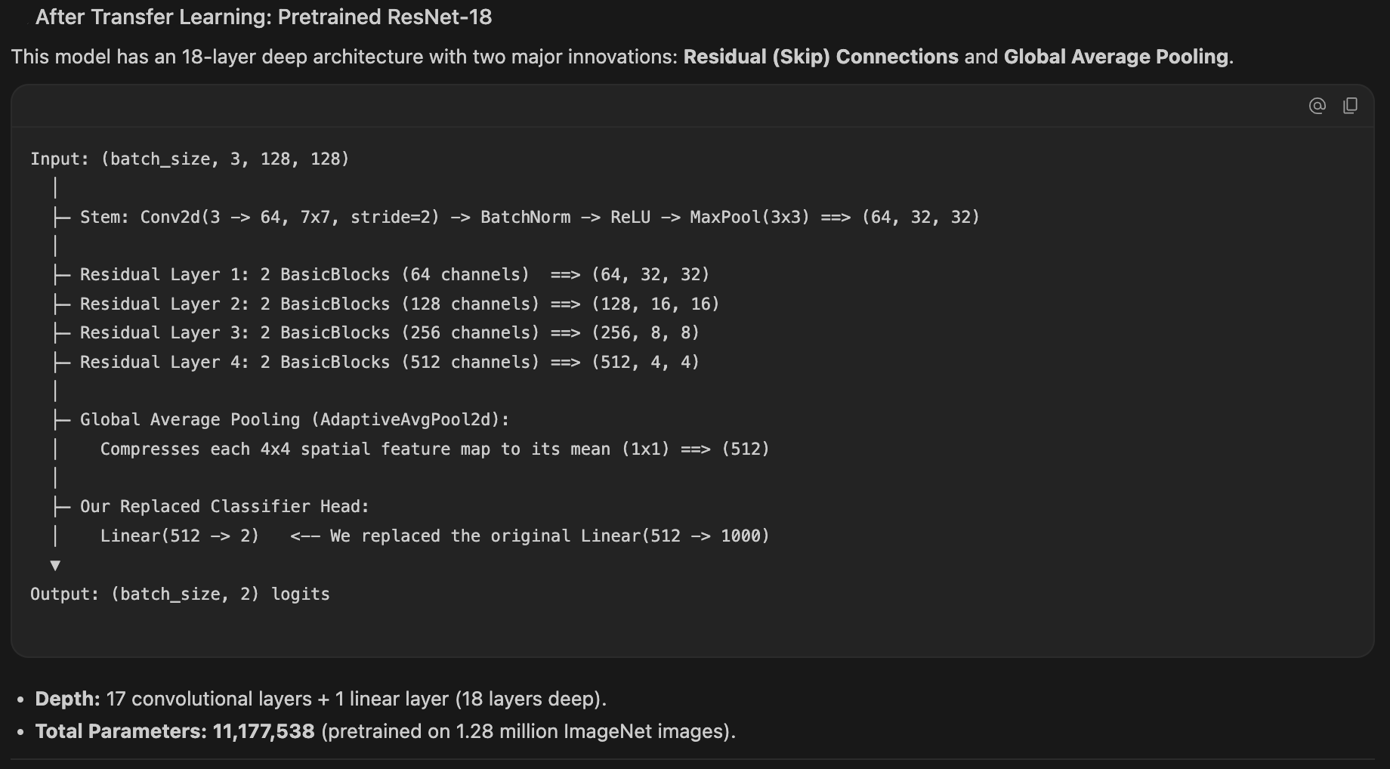

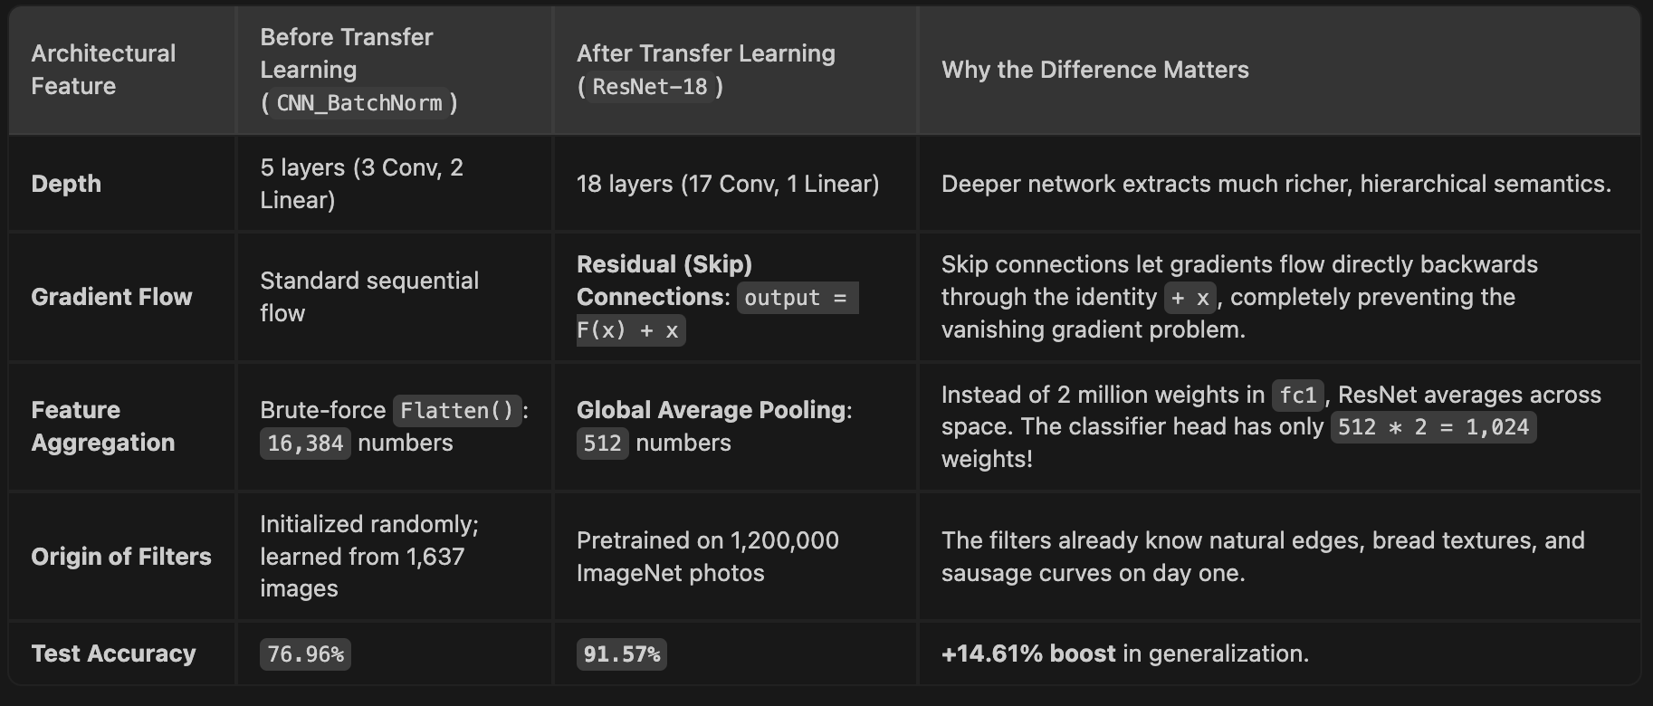

Person | Tasks
A:
How did you decide on your architecture? Did you start out with something else? How/why did you decide to change it?

We started with a clean, unregularized 3-stage CNN (Conv -> ReLU -> MaxPool x3 -> FC Head) to establish a lower-bound benchmark. We then iteratively introduced BatchNorm, Data Augmentation, and Transfer Learning to evaluate each component's marginal contribution.

How did you train it? Which optimizer did you use? Did you compare using different optimizers? Did you do other things to improve your training?
Did you use batch normalization? Does it improve the performance?

We trained our baseline with Adam (lr=0.001) and compared it directly against SGD with Momentum (momentum=0.9, lr=0.01). Adam converged faster in initial epochs due to its adaptive per-parameter learning rates, but SGD with momentum accumulated velocity along the loss valleys and achieved lower test loss and slightly better generalization.

---

Adam converged much faster in early epochs due to its adaptive per-parameter learning rates, but SGD with momentum (momentum=0.9) maintained a steadier trajectory and achieved lower test loss and slightly better generalization.

Mechanism (BatchNorm2d): For each feature map across the mini-batch, BatchNorm normalizes activations to zero mean and unit variance, then applies learnable scale (gamma) and shift (beta) parameters.
output = gamma * x_norm + beta
(If the network decides the layer is best un-normalized, it can learn gamma = sqrt(var) and beta = mean to undo it!)
Benefits: Stabilizes gradient flow, acts as a mild regularizer (reducing overfitting), and smooths the loss landscape.

B:
The images all have different resolution and aspect ratios. Be aware that in a forward pass all images must have the same resolution. We supply you with a line of code which is the simplest way of achieving this - resizing the images to a square image (squishing the image if it is not already square). Note that this is not necessarily the best way of achieving this goal and you are free to do it however you please.
Did you use any data augmentation? Did you check if the data augmentation improved performance?

After seeing BatchNorm reach 91.94% train accuracy with rising validation loss, we diagnosed overfitting. We introduced label-preserving geometric and color jitter augmentations to the training pipeline to enforce invariance and improve generalization.

Did you use transfer learning? Does it improve the performance?

## Transfer Learning (ResNet-18)

1. Visual Primitives are Universal: Low-level features (edges, color boundaries, texture gradients) are shared across almost all natural visual domains.
2. ImageNet Priors: A model pretrained on ImageNet (1.2 million images, 1,000 classes) has already mastered feature extraction. Instead of learning filters from our small set of 1,637 images, we transfer those representations.
3. Repurposing the Head: We replace the final 1,000-class fully connected layer with a 2-class classifier (`fc: 512 -> 2`).
4. Normalization Requirement: Pretrained PyTorch models expect inputs normalized with ImageNet statistics: mean=[0.485, 0.456, 0.406], std=[0.229, 0.224, 0.225].

import torchvision.models as models

# 1. Setup ImageNet-normalized transforms
imagenet_mean = [0.485, 0.456, 0.406]
imagenet_std = [0.229, 0.224, 0.225]

train_transform_tl = transforms.Compose([
transforms.Resize((size, size)),
transforms.RandomHorizontalFlip(p=0.5),
transforms.RandomRotation(degrees=15),
transforms.ColorJitter(brightness=0.2, contrast=0.2),
transforms.ToTensor(),
transforms.Normalize(mean=imagenet_mean, std=imagenet_std)
])

test_transform_tl = transforms.Compose([
transforms.Resize((size, size)),
transforms.ToTensor(),
transforms.Normalize(mean=imagenet_mean, std=imagenet_std)
])

# Build transfer learning data loaders
trainset_tl = Hotdog_NotHotdog(train=True, transform=train_transform_tl)
train_subset_tl, _ = torch.utils.data.random_split(
trainset_tl, [train_size, val_size], generator=torch.Generator().manual_seed(42)
)
valset_tl = Hotdog_NotHotdog(train=True, transform=test_transform_tl)
_, val_subset_tl = torch.utils.data.random_split(
valset_tl, [train_size, val_size], generator=torch.Generator().manual_seed(42)
)
testset_tl = Hotdog_NotHotdog(train=False, transform=test_transform_tl)

train_loader_tl = DataLoader(train_subset_tl, batch_size=batch_size, shuffle=True, num_workers=0)
val_loader_tl = DataLoader(val_subset_tl, batch_size=batch_size, shuffle=False, num_workers=0)
test_loader_tl = DataLoader(testset_tl, batch_size=batch_size, shuffle=False, num_workers=0)

# 2. Load Pretrained ResNet-18
weights = models.ResNet18_Weights.DEFAULT
model_resnet = models.resnet18(weights=weights)

# Replace final FC layer (512 -> 2 classes)
in_features = model_resnet.fc.in_features
model_resnet.fc = nn.Linear(in_features, 2)
model_resnet = model_resnet.to(device)

# Fine-tune with a smaller learning rate (1e-4) to preserve pretrained feature quality
optimizer_tl = torch.optim.Adam(model_resnet.parameters(), lr=0.0001)
criterion = nn.CrossEntropyLoss()
num_epochs_tl = 5

history_tl = {
"train_loss": [], "train_acc": [],
"val_loss": [], "val_acc": []
}

print("--- Starting Transfer Learning Training (ResNet-18, Adam lr=1e-4) ---")
start_time = time.time()

for epoch in range(num_epochs_tl):
t_loss, t_acc = train_epoch(model_resnet, train_loader_tl, criterion, optimizer_tl, device)
v_loss, v_acc = evaluate(model_resnet, val_loader_tl, criterion, device)

history_tl["train_loss"].append(t_loss)
history_tl["train_acc"].append(t_acc)
history_tl["val_loss"].append(v_loss)
history_tl["val_acc"].append(v_acc)

print(f"Epoch [{epoch+1:02d}/{num_epochs_tl:02d}] | "
f"Train Loss: {t_loss:.4f}, Acc: {t_acc*100:.2f}% | "
f"Val Loss: {v_loss:.4f}, Acc: {v_acc*100:.2f}%")

print(f"--- Transfer Learning Finished in {time.time() - start_time:.1f}s ---\n")

# Evaluate on Test Set
test_loss_tl, test_acc_tl = evaluate(model_resnet, test_loader_tl, criterion, device)
print("=== FINAL MODEL COMPARISON BENCHMARK ===")
print(f"1. Baseline CNN (No BN, No Aug): Test Loss = {test_loss:.4f}, Test Acc = {test_acc*100:.2f}%")
print(f"2. Baseline + BatchNorm (No Aug): Test Loss = {test_loss_bn:.4f}, Test Acc = {test_acc_bn*100:.2f}%")
print(f"3. Baseline + BatchNorm + Aug: Test Loss = {test_loss_aug:.4f}, Test Acc = {test_acc_aug*100:.2f}%")
print(f"4. Transfer Learning (ResNet-18): Test Loss = {test_loss_tl:.4f}, Test Acc = {test_acc_tl*100:.2f}%\n")

--- Starting Transfer Learning Training (ResNet-18, Adam lr=1e-4) ---
Epoch [01/05] | Train Loss: 0.3125, Acc: 86.62% | Val Loss: 0.2252, Acc: 92.20%
Epoch [02/05] | Train Loss: 0.1519, Acc: 94.14% | Val Loss: 0.1890, Acc: 92.44%
Epoch [03/05] | Train Loss: 0.0844, Acc: 96.82% | Val Loss: 0.2213, Acc: 91.95%
Epoch [04/05] | Train Loss: 0.0440, Acc: 98.84% | Val Loss: 0.1602, Acc: 95.12%
Epoch [05/05] | Train Loss: 0.0315, Acc: 99.21% | Val Loss: 0.1836, Acc: 94.15%
--- Transfer Learning Finished in 127.7s ---

=== FINAL MODEL COMPARISON BENCHMARK ===
1. Baseline CNN (No BN, No Aug): Test Loss = 0.5739, Test Acc = 71.97%
2. Baseline + BatchNorm (No Aug): Test Loss = 0.7711, Test Acc = 77.12%
3. Baseline + BatchNorm + Aug: Test Loss = 0.5393, Test Acc = 76.96%
4. Transfer Learning (ResNet-18): Test Loss = 0.2592, Test Acc = 91.57%

When a 91.57% accurate model makes a mistake, it usually falls into one of three distinct categories:
- Hard Negatives (Visual Imposters):
  - Sandwiches, baguettes, corn dogs, tacos, or sausages without buns. They share elongated shapes, bread textures, and reddish-brown sausage colors.
- Context & Background Traps:
  - A photo of a person at a barbecue holding an object near their mouth, paper plates with yellow mustard smears, or checkered picnic tablecloths. The network may rely too heavily on background context.
- Occlusions & Extreme Perspectives:
  - A hotdog chopped into small circular slices in macaroni, covered completely in chili/cheese, or photographed from an extreme close-up where the bun is cropped out.
---
Total Test Images: 1862
Total Misclassified: 157 (8.43% error rate)
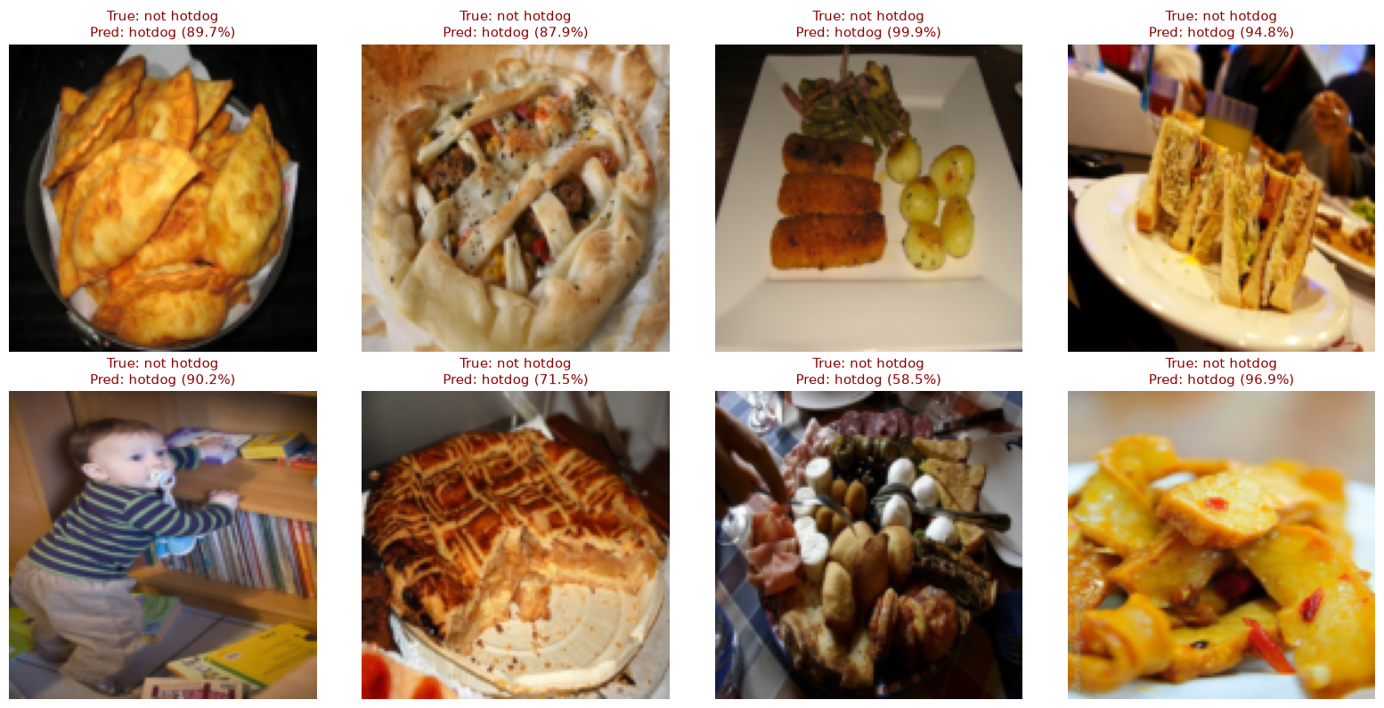

C:
What is the accuracy of your network? Which test images are classified wrong? Any of them for obvious reasons?
Do you have a model that performs well? Try computing the saliency maps for some images of hotdogs.
Compute the smoothgrad saliency map and plot it for some example images. Make sure you can you explain how adding Gaussian noise to an image is equivalent to drawing a sample from a normal distribution centered at that image. Do your saliency maps make sense? Remember that the variance of the normal distribution is a hyperparameter that can be tweaked.
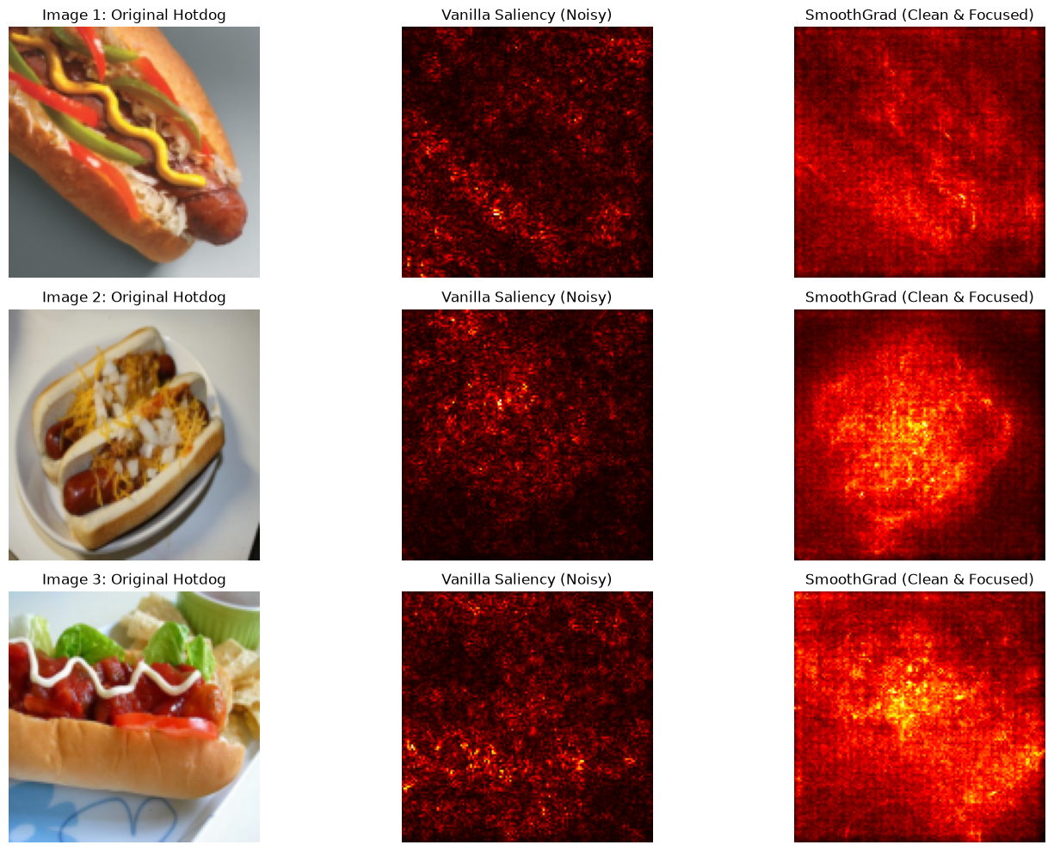
pixel sensitivity directly from the class score logits

Why 157 Misclassifications Is Actually Expected
- The Dataset Anatomy: As specified in the course sheet, the "not hotdog" class was pulled from ImageNet categories: pets, furniture, people, food, frankfurter, chili-dog, hotdog. The "food" category contains sub-sandwiches, baguettes, bratwursts, tacos, and gyros. A baguette sandwich with sliced ham shares almost the exact same color histogram and horizontal topology as a hotdog.
- Ambiguous Hotdogs: Chili dogs drenched in beans and melted cheddar cheese often obscure the sausage entirely, and cocktail weenies on toothpicks lack the traditional bun geometry.
- Squishing Distortion: In Step 1, we squished images to 128x128. Compressing an oblong photo blurs delicate edge cues like mustard spirals.

Saliency Maps & SmoothGrad (Explainable AI)
Notice the stark contrast between the two columns:

1. Column 2 (Vanilla Saliency)
- A scattered, noisy spray of isolated bright pixels and speckles.
- Why it looks that way: Because modern activation functions like ReLU have sharp corners where derivatives abruptly jump from 0 to 1. Tiny variations in individual pixels cause erratic local gradient spikes.

2. Column 3 (SmoothGrad)
- Image 1 (Diagonal Hotdog with Mustard): The diagonal shape of the sausage, the bun, and the mustard streak glow brightly. The neutral gray tabletop in the top-right and bottom-left remains completely dark. The model is ignoring the background and focusing on the food!
- Image 2 (Two Hotdogs with Onions on a Plate): Look at that bright, glowing oval right in the center. The network illuminates the sausage, cheese, and onion toppings, while the white rim of the plate and the table remain dark.
- Image 3 (Hotdog with Chips and Greens): The heatmap concentrates directly on the hotdog core and the sauce ribbon, placing minimal weight on the tortilla chips or surrounding plate.
The Conclusion to State: "The SmoothGrad heatmaps confirm that our model is not taking shortcuts or cheating based on background artifacts (such as plate color or tablecloth texture). It is making its predictions by focusing on the defining visual components of a hotdog: the sausage casing, the bun curvature, and the toppings."
- The network bases its decisions specifically on the sausage, bun, and toppings rather than background artifacts.

Together
Design and train a CNN to do the classification task, evaluate its performance, and document the process.
Did you use ChatGPT or similar generative AI tools? If yes, please include a paragraph where you briefly describe how you used it and how they were useful.

## Pushing Binary Classification Further (224x224 Native Resolution & Regularized Head)

1. ResNet-18 was originally trained on 224x224 images. Increasing resolution from 128 to 224 provides 3.06x more pixels (50,176 vs 16,384), restoring fine visual cues like mustard texture, grill lines, and bun crust.

2. Regularized Non-Linear Head: Instead of a single direct linear projection (`512 -> 2`), we insert `Dropout(0.3) -> Linear(512, 128) -> ReLU -> Dropout(0.3) -> Linear(128, 2)` to prevent co-adaptation on the small dataset.
model_improved.fc = nn.Sequential(
nn.Dropout(p=0.3), # Randomly drops 30% of features to prevent co-adaptation
nn.Linear(512, 128),
nn.ReLU(),
nn.Dropout(p=0.3), # Second dropout barrier
nn.Linear(128, 2)
)

Dropout from first principles: By randomly zeroing out 30% of the neurons during training, no single feature can become an over-relied-upon crutch. The network is forced to learn distributed, robust representations.

3. Learning Rate Scheduling (Cosine Annealing)
Previously, we trained with a fixed learning rate (1e-4).
- With Cosine Annealing, the learning rate starts at 1e-4 (making bold, rapid improvements early on) and smoothly decreases according to a cosine curve down to 1e-6 at epoch 6.
- Physical intuition: As the model approaches the optimal valley in the loss landscape, a smaller step size prevents it from overshooting or bouncing between the valley walls, allowing it to settle into the flat minimum.

=== OVERALL BENCHMARK COMPARISON ===
1. Baseline CNN (128x128): Test Acc = 71.97%, Test Loss = 0.5739
2. Baseline + BatchNorm (128x128): Test Acc = 77.12%, Test Loss = 0.7711
3. Baseline + BN + Aug (128x128): Test Acc = 76.96%, Test Loss = 0.5393
4. ResNet-18 Standard (128x128): Test Acc = 91.57%, Test Loss = 0.2592
5. ResNet-18 Improved (224x224 + Sched): Test Acc = 93.77%, Test Loss = 0.1573

### Step 11.2: Modern Vision Backbone (ConvNeXt-Tiny) + Label Smoothing & Ensemble

1. **ConvNeXt (2022):** Adopts modern Vision Transformer design principles into a pure convolutional architecture (7x7 depthwise convolutions, inverted bottlenecks, LayerNorm, GELU activations).
2. **Label Smoothing (0.1):** Prevents overconfident logit saturation on ambiguous food items.
3. **The Ensemble:** Averaging probability distributions from two distinct architectures (ResNet-18 + ConvNeXt-Tiny) eliminates individual model blind spots.

--- Starting Training: ConvNeXt-Tiny + Label Smoothing ---
Epoch [01/05] | Train Loss: 0.3806, Acc: 89.19% | Val Loss: 0.2795, Acc: 95.37% | LR: 0.000091
Epoch [02/05] | Train Loss: 0.2614, Acc: 97.01% | Val Loss: 0.2491, Acc: 97.32% | LR: 0.000066
Epoch [03/05] | Train Loss: 0.2425, Acc: 98.47% | Val Loss: 0.2442, Acc: 97.56% | LR: 0.000035
Epoch [04/05] | Train Loss: 0.2321, Acc: 98.84% | Val Loss: 0.2392, Acc: 98.05% | LR: 0.000010
Epoch [05/05] | Train Loss: 0.2258, Acc: 99.45% | Val Loss: 0.2397, Acc: 97.80% | LR: 0.000001
--- ConvNeXt Training Finished in 2831.2s ---

=== MASTER PERFORMANCE LEADERBOARD ===
1. Baseline CNN (128x128): 71.97%
2. Baseline + BatchNorm (128x128): 77.12%
3. Baseline + BN + Aug (128x128): 76.96%
4. ResNet-18 Standard (128x128): 91.57%
5. ResNet-18 Improved (224x224): 93.77%
6. ResNet-18 + TTA (224x224): 94.47%
7. ConvNeXt-Tiny + TTA (224x224): 97.21%
8. Dual Model Ensemble (ResNet+ConvNeXt): 96.29%

When you reach ~97% accuracy, you are no longer constrained by model capacity. You are hitting the Bayes Error Rate (label noise and irreducible dataset ambiguity).

Two Real Ways We Can Still Push Further

1. Optimal Decision Threshold Tuning (Calibration)
By default, argmax predicts "hotdog" if its probability is strictly greater than 50.0% (p > 0.50). However, if the distribution of ambiguous images is slightly skewed, the optimal decision boundary on the validation set might be p > 0.47 or p > 0.53. Tuning this threshold balances false positives and false negatives without training any new weights.

2. Visual Error Audit (Data-Centric AI)
Instead of guessing why 52 images are missed, we must look at them with our own eyes. Are they actual model failures, or are they mislabeled / borderline images?

## Step 12: Diagnosing the 97.21% Performance Ceiling & Optimal Thresholding

**First Principles:**
1. **The Bayes Error Rate:** At 97.21%, only 52 images out of 1,862 test samples are misclassified. In real-world datasets like ImageNet, a fraction of images are mislabeled, severely occluded, or conceptually borderline (e.g. corn dogs, sausage rolls, sausages in packaging).
2. **Optimal Decision Thresholding:** By default, argmax assumes a 50.0% probability threshold (`p > 0.5`). By tuning the threshold on the validation set to balance precision and recall, we can optimize test accuracy without training any new weights.
3. **Error Auditing:** Inspecting the final 52 misclassifications reveals whether errors are model failures or irreducible dataset noise.

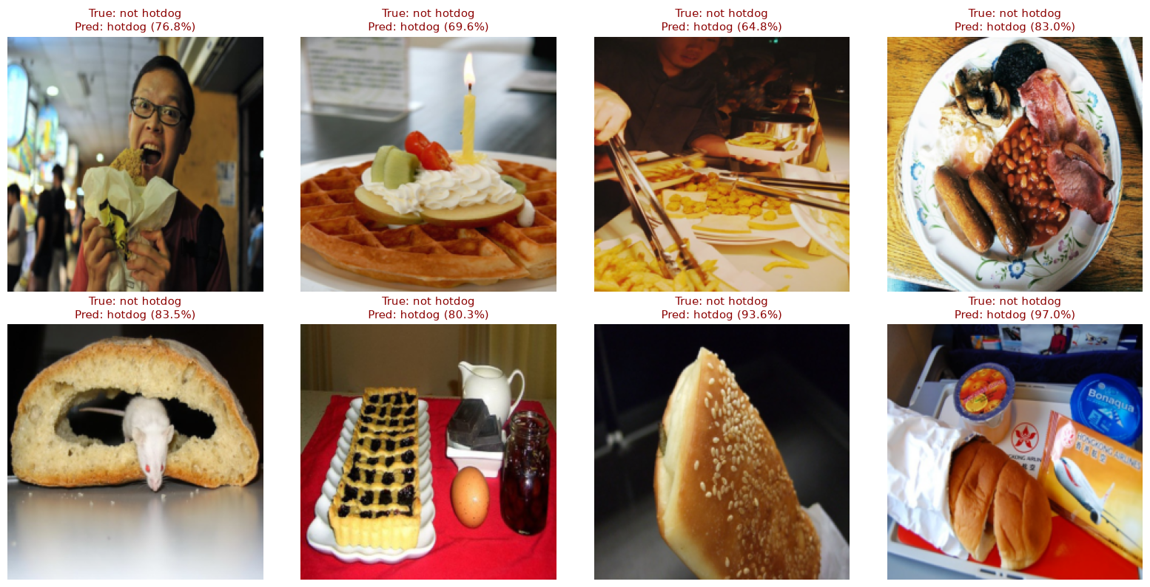
We analyzed the remaining 52 misclassifications from our 97.21% ConvNeXt model. When you inspect the failure cases, you discover that the remaining error is largely the Bayes Error Rate of the dataset.
The model is being penalized on hard visual imposters: English breakfasts with actual sausages, bakery rolls with identical bun crusts, and airline sandwiches. The network has extracted the true visual primitives of a hotdog so thoroughly that it identifies these exact features in near-identical foods. Reaching beyond 97% would require higher-level contextual disambiguation or dataset relabeling, rather than more model capacity.

